Paired Code Review Record (Blank Template)

TechSolutions Intranet – Maintenance Log Feature

1. Review Details
Author: Olly Powell
Reviewer: Kian O’meara
Date: 29/01/2026
Files / Components Reviewed:
Index.HTML
static

Version / Commit (if used): Final commit

2. Review Objective
(What requirement, KPI, or acceptance criterion is this review checking?)
Check whether the HTML code meets the requirements to save complete, accurate records with clear validation/error messages and robust handling of invalid inputs, aligned KPIs:
- >90% entries completed without correction on first attempt
- Clear messages enabling self-recovery without support
- No missing mandatory fields on save

3. Start and End Conditions
Start Condition:
Reviewer has access to the repo and HTML file

End Condition:
Review checklist completed, findings evidenced, and a prioritised change list produced and shared with the author

4. Findings Checklist

A. Functionality & Logic
(Errors, incorrect outcomes, missing logic, unexpected behaviour)
- No issues with the functionality of the HTML

Evidence (line numbers / screenshot):

B. Code Organisation
(Naming, structure, readability, comments)
- Little comments that add clarity

Evidence:
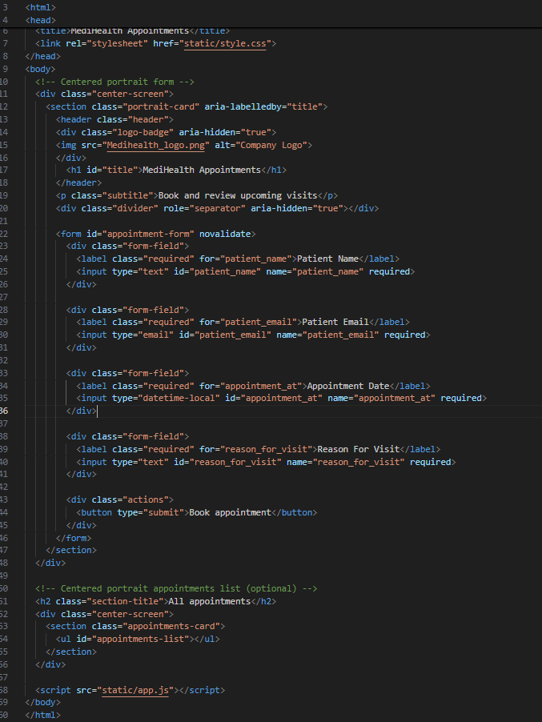

C. Validation & Error Handling
(Missing validation, unclear messages, poor handling of edge cases)
- Validation works but displays incorrect error message for most cases

Evidence:
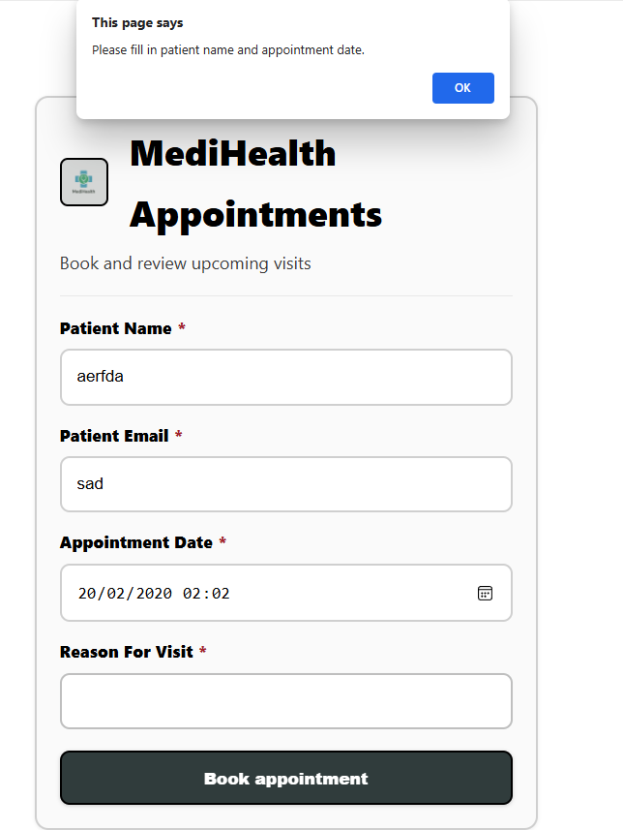

D. Efficiency
(Repeated code, unnecessary complexity, performance concerns)
- All good

Evidence: __________________________________________

E. Data Handling & Security
(Incorrect database operations, unsafe input handling, potential leaks)
- No issues with data security or handling

Evidence: __________________________________________

F. Standards, Accessibility & Legal Considerations
(Clarity of system messages, compliance with accessibility expectations, safe handling of information)
- Compliant with expectations and handles information safely

Evidence: __________________________________________

G. Testing & Edge Case Coverage
(Missing tests, untested conditions, failing behaviours)
- No issues with tests

Evidence: __________________________________________

5. Prioritised Improvements
Issue Identified | Proposed Fix | Priority (P1 / P2 / P3) | Linked Requirement/KPI
Incorrect Error messages | Fix them | P2 | Dunno
Lacking comments in code | Add more comments | P2 | Easy to read

6. Reviewer Summary (Short)
(Top 3 issues + impact on the system)
- Missing comments that would otherwise add clarity to the code
- Error message is the same for any error caught with validation

Overall Summary:
Is good, just needs some tweaks to push it further

7. Author Response (Optional)
(Accept / Decline each suggestion + rationale)
I accept the response of the reviewer, they gave me clear feedback of what needs to be done next to improve it further and to make it perfect for all users to be able to use.

